CS540

Matthew Getter

**Instructions/Description**

**How to Install FCC Towers to Postgres and QGIS**

*Please use these instructions in conjunction with the guided video.

1. Go to my Github:

<https://github.com/Dancekonig/CS540-Task3.git>

Download the zip file “fcctowers.zip”, then extract into: c:\temp\cs540\gis .

1. Edit the get_load batch file in gis folder, type/copy:



1. Then run this code in CMD . (# This loads data to Postgres (pg Admin))

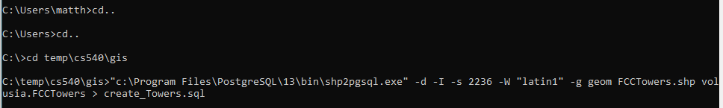



This is the attribute table in pg admin to understand the columns and values in dataset.

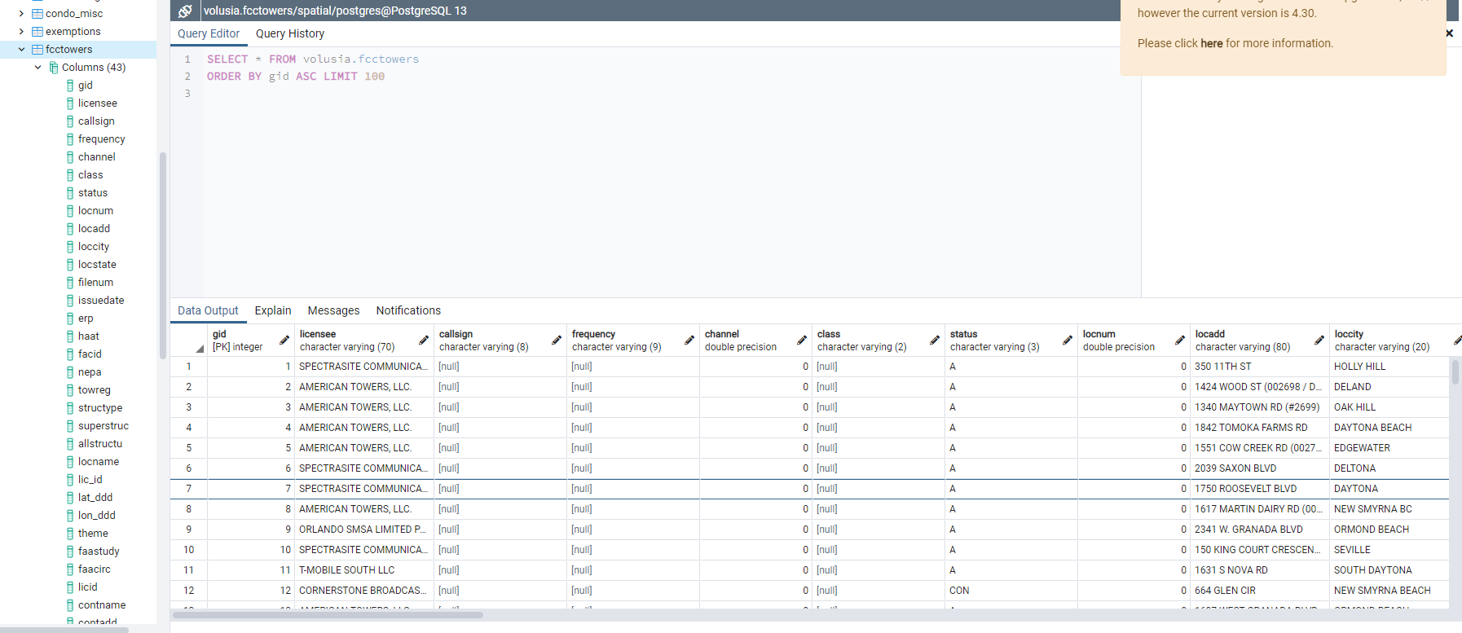

1. Open QGIS and add a PostGIS Layer with the connected “fcctowers” dataset.

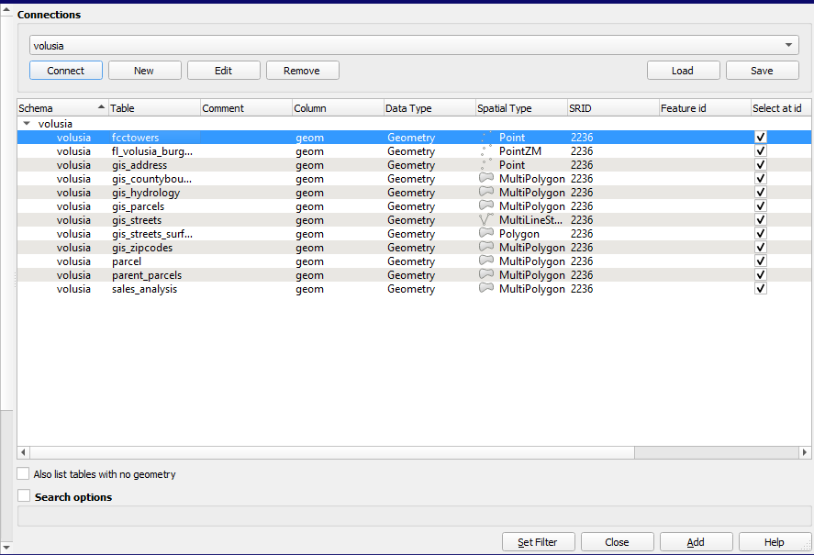

1. Once the “fcctowers” layer is added, Open DBManager and run any of the following Queries: (# This will find the 15 closest FCC Towers to the desired altkey)

Any of these quries show the same results. (# Confirmation with fcctower layer.)

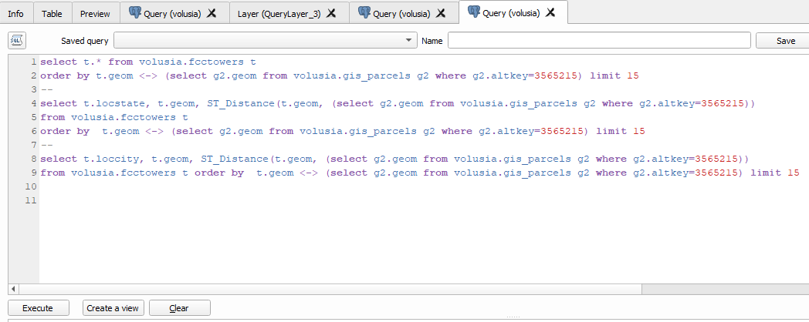

1. Attempt at finding closest parcel by a given Tower and it’s gid number:(#endless query load)

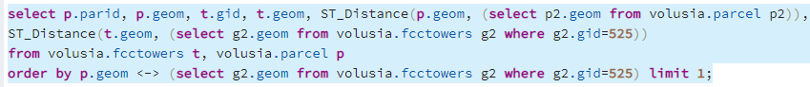

1. Add column in parcel table:



1. Update the geometry to parcel table:



1. Update towerdistance column for given parid: (#endless query loading) table didn’t update!



**Alternative:** Instead changed towerdistance to binary: (#this shows parcels that interect within 300M of a FCC Tower. Classifies parcels if they are in risk of tower proximity.



#Codes shows 2000ft= 600M, but I chose 1000ft=300Meters.

1. Add PostGIS layer for volusia.parcels: categorize for towerdistance in properties=binary map



1. **(optional)** change the properties and symbology of new Qgis Layers to get: a buffer for Cell area coverage./ Distance to a tower if a residence is too close for health reasons.

These buffers can be added in two easy ways. The third way can be done via SQL but requires definitive x,y gis points to create a single buffer.

* First way: Choose circle shape in properties and use ‘Meters at scale’. (#Double the desired distance for accuracy. Eg. For 300M area you put 600 in Size.)

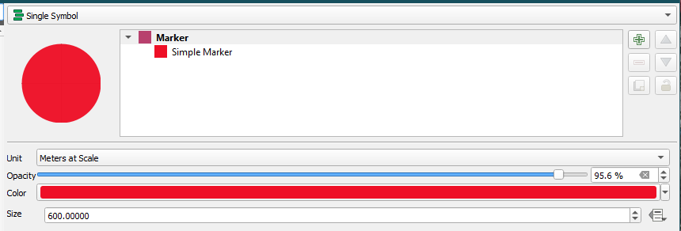

* Second Way: Vector>Geoprocessing Tools> Buffer. (# This is just a temporary layer.)

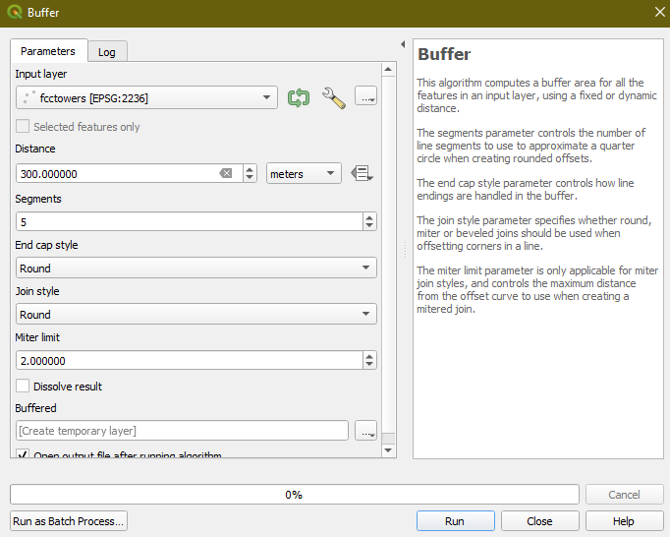

1. **End Results:**

The following pictures should show the same results as instructed above:

15 closest FCC towers to Embry Riddle (Altkey= 3304268):

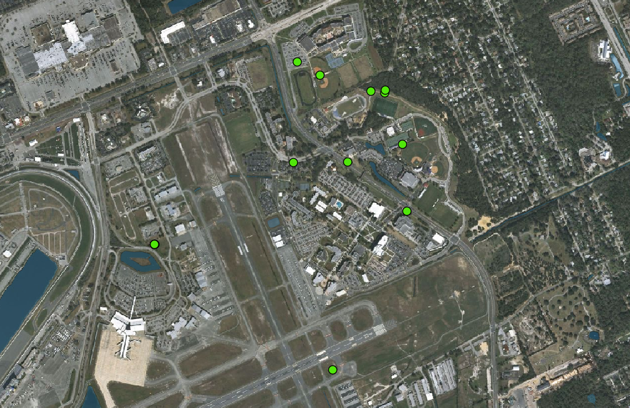

Show all Towers for confirmation (#overlap):

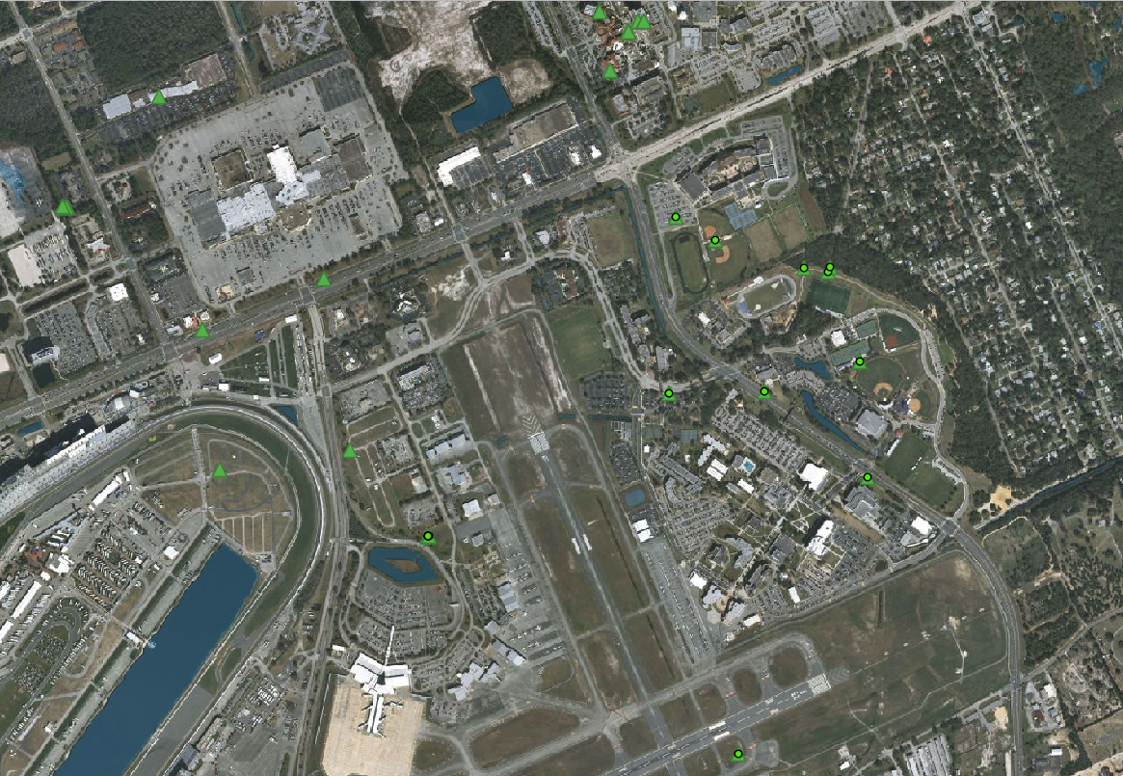

With Optional Symbology/Properties, find a buffer: Red depicting health risk @300M radius and Yellow @600M radius presenting a medium/cautionary zone for a living area.

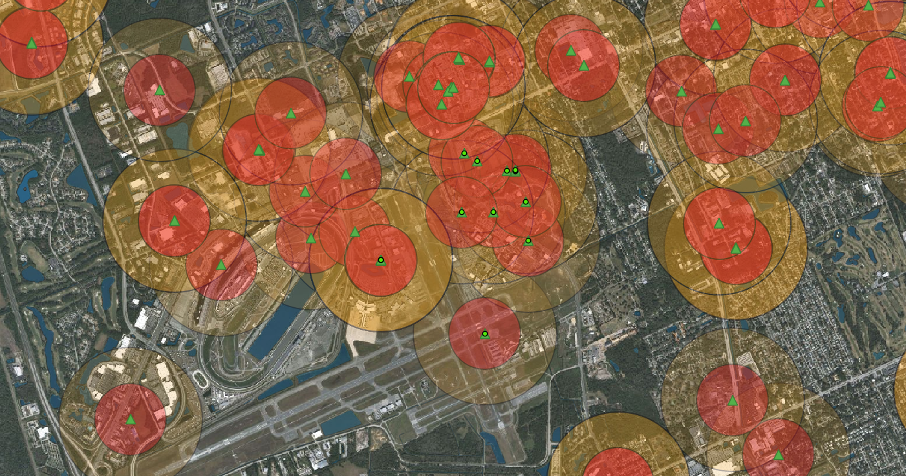

Highlighted parcel shows Embry Riddle: Relatively close to many towers and in 3 red zones.

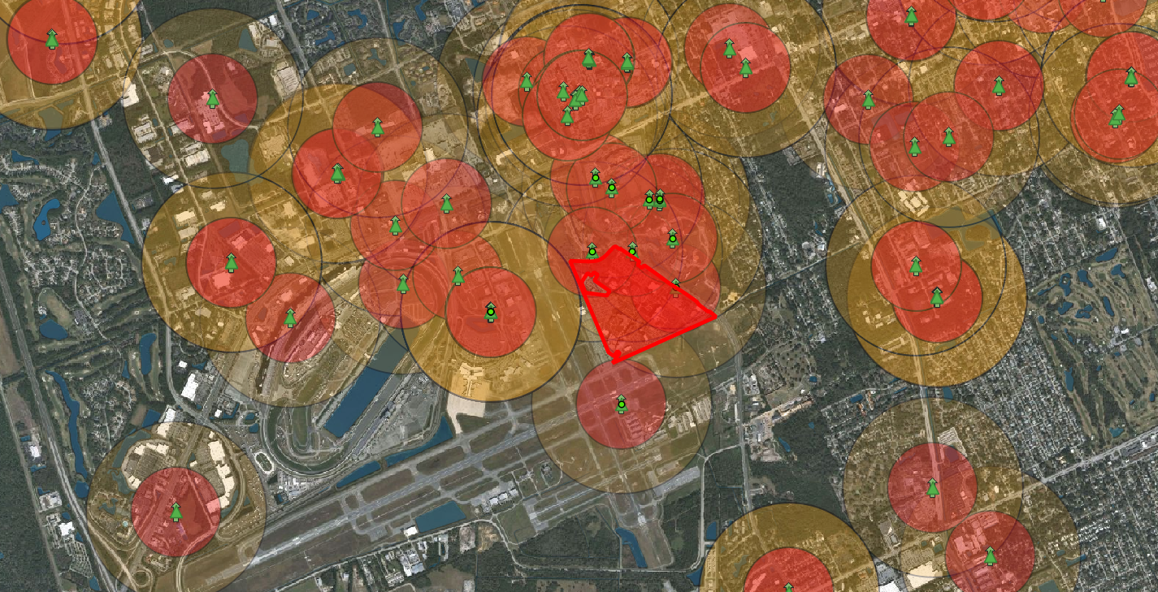

Finding Maximum Cell area/coverage in Volusia County (w/ overlap) @ 35405 Meters:

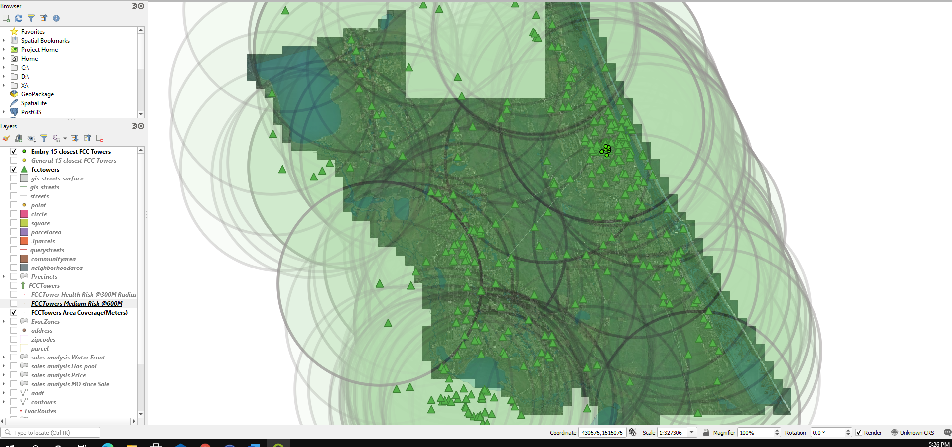

Binary Parcel/FccTower Intersection @300M: Shows towerdistance column in binary where parcels that intersect within 300M of an FCC Tower are highlighted red. This classifies the parcels in two, so you know whether a living area is at risk of tower proximity.

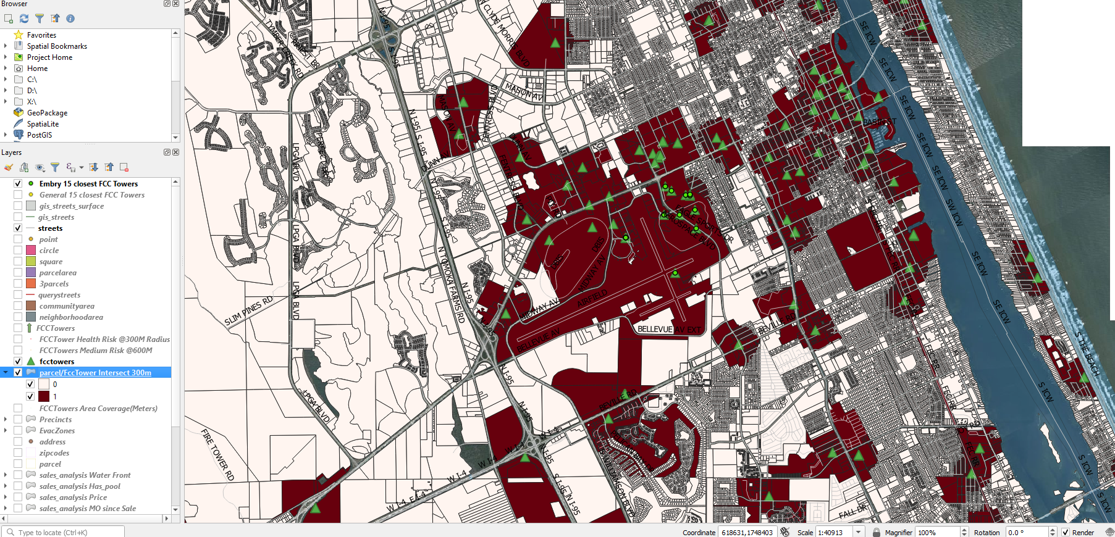

END